Bulletin de vote CE2 – CM1

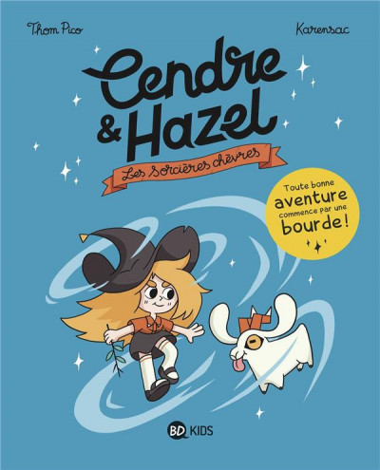 |  | 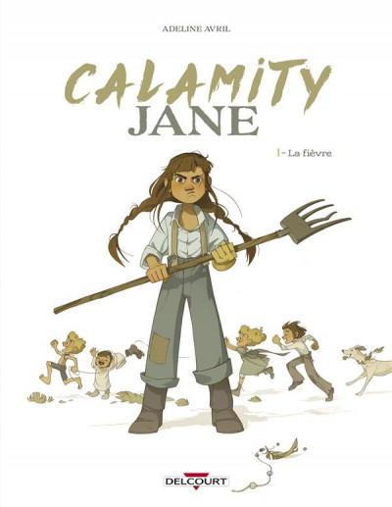 |  | 
 |  |  |  | 

 |  | 
 |  | 

Bulletin de vote CE2 – CM1

 |  |  |  | 

 |  | 

