Bulletin de vote CM2 – 6e

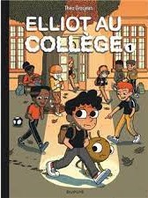 |  |  |  | 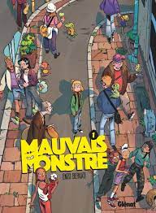
 |  |  |  | 

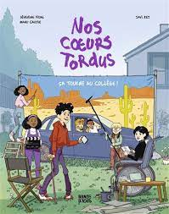 |  | 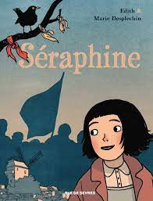
 |  | 

Bulletin de vote CM2 – 6e

 |  |  |  | 

 |  | 

